Project Design Phase-II
Data Flow Diagram & User Stories

Date | 27 JUNE 2025
Team ID | NM2025TMID00377
Project Name | Calculating Family Expenses using Service Now
Maximum Marks | 4 Marks

Data Flow Diagrams:
A Data Flow Diagram (DFD) represents how data flows within the Family Expense Calculation System built on ServiceNow. It shows user interactions for adding, categorizing, and calculating expenses. The system processes these inputs, stores data in the expense database, and generates monthly and yearly reports for better financial tracking and analysis.

Example:
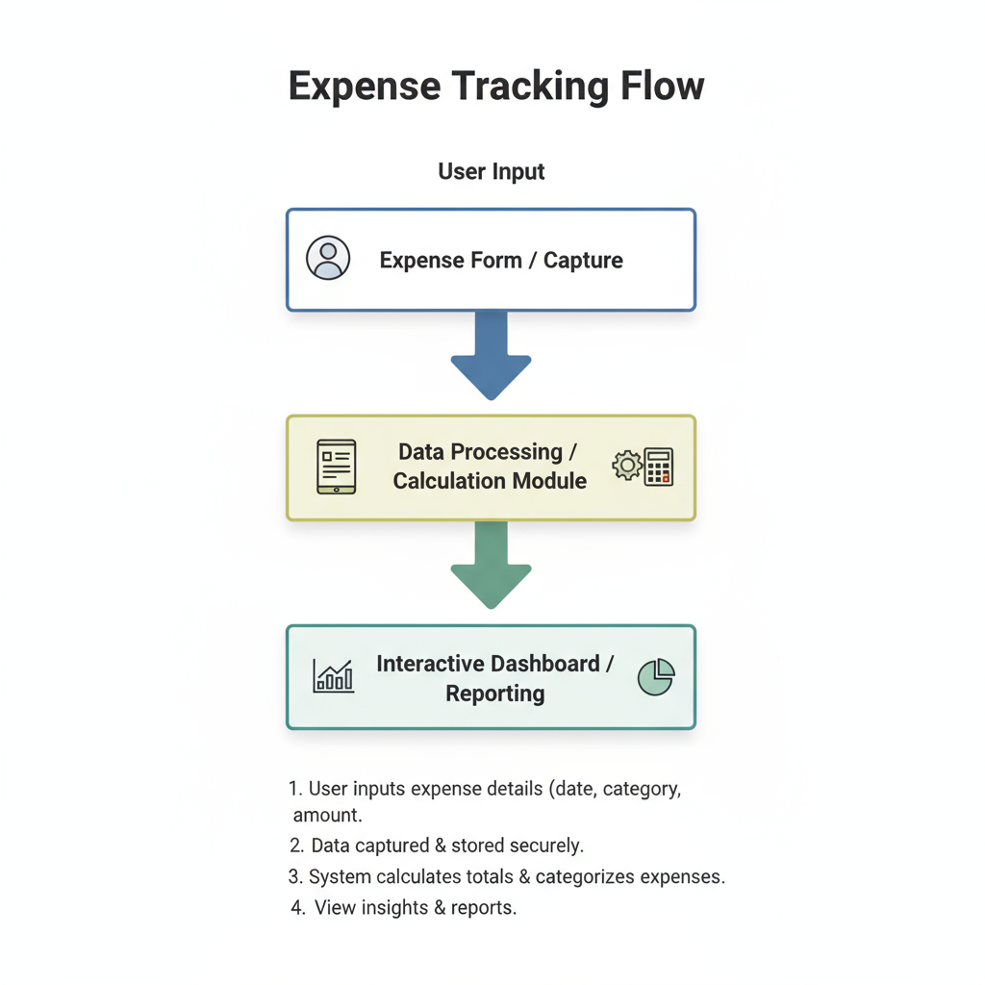
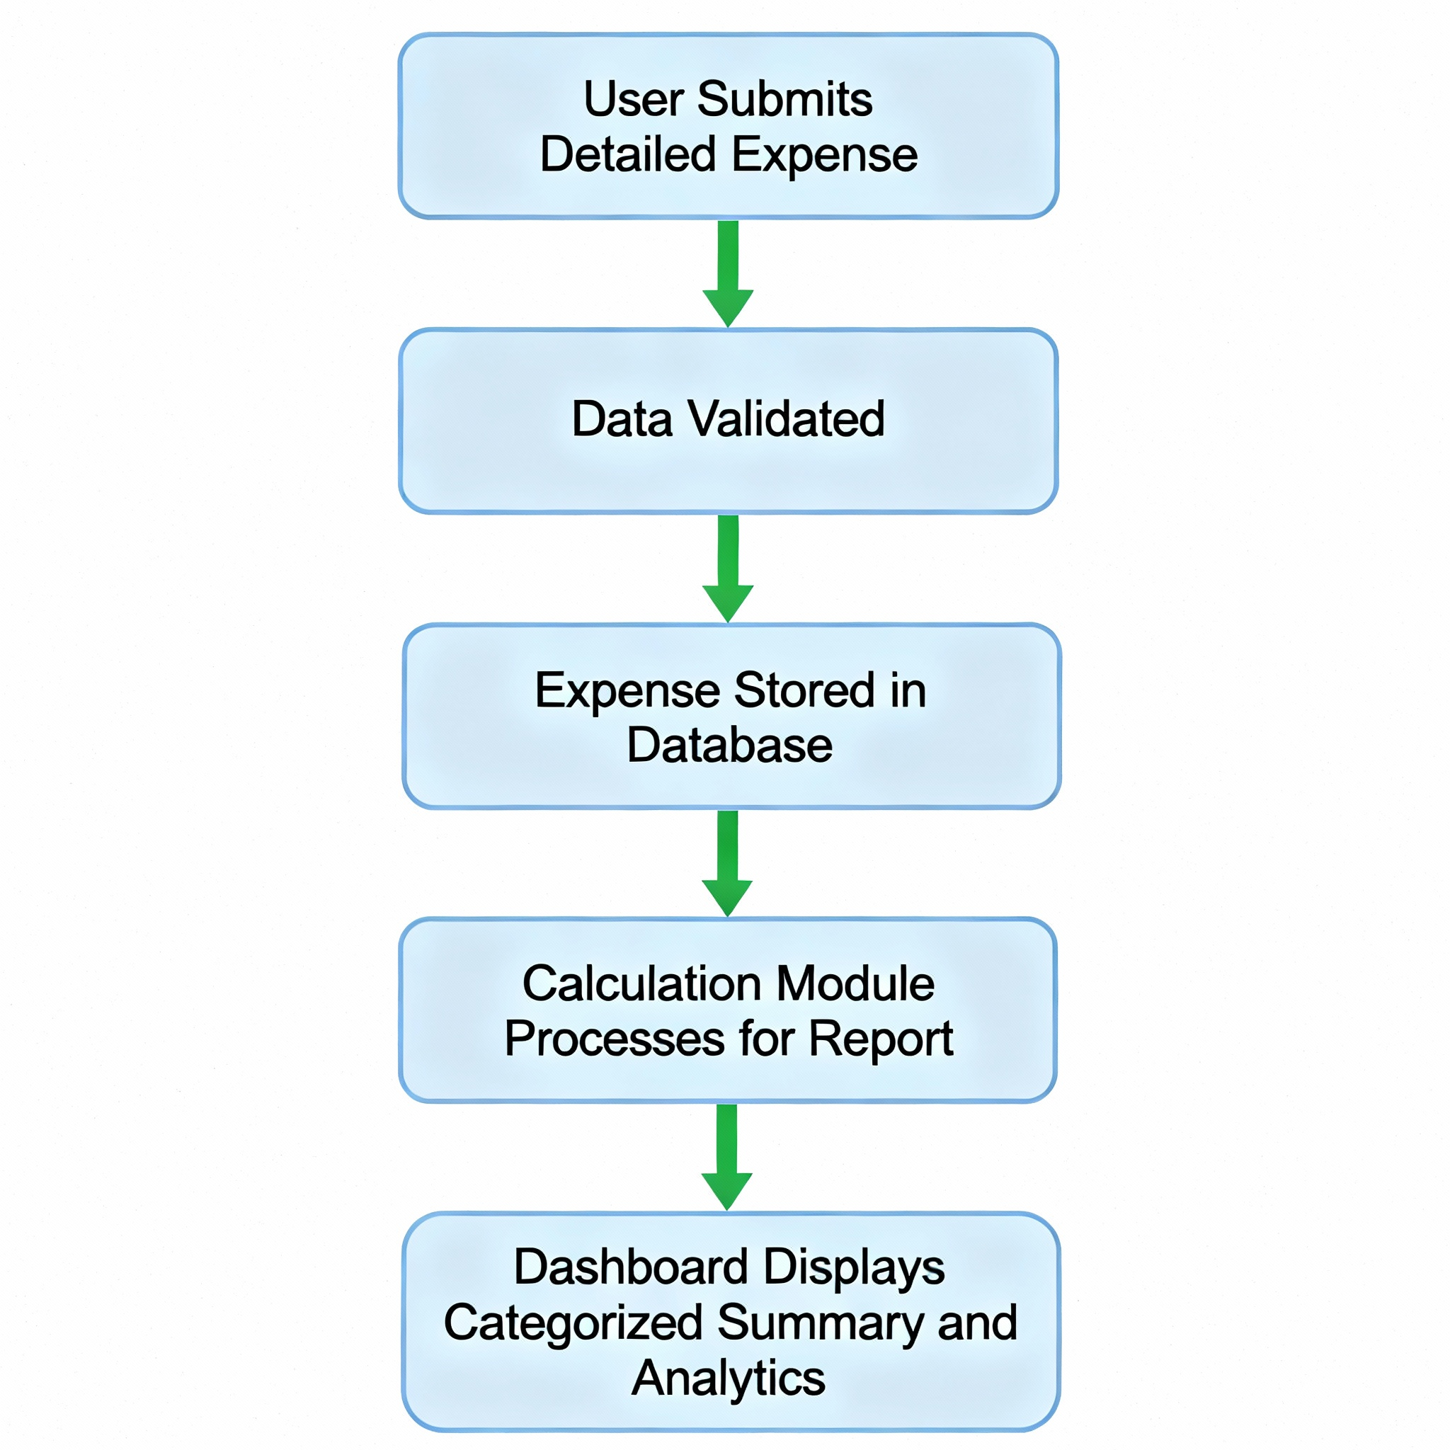

User Stories:
User stories describe what each type of user expects from the Family Expense Calculation System in simple, goal-oriented terms. They capture how family members and admins interact with the system through specific features.

User Type | Functional  Requirement (Epic) | User Story Number | User Story / Task | Acceptance criteria | Priority | Release
Family Member | Expense Entry | USN-1 | As a user, I want to enter daily expenses with category and amount. | The system should allow adding expenses and saving them successfully. | High | Sprint-1
System | Expense Calculation | USN-2 | As a system, I should automatically calculate total and categorized expenses. | Totals must update automatically when new data is entered. | High | Sprint-2
Family Member | Dashboard | USN-3 | As a user, I want to view monthly and yearly expense summaries on a dashboard. | Dashboard must display accurate, updated visual summaries. | High | Sprint-3
Admin | Budget Setup | USN-4 |  | System should trigger alerts when expenses cross budget limits. | Medium | Sprint-3
  As an admin, I want to set monthly budget
  limits and get alerts when exceeded.
User | Data Export | USN-5 | As a user, I want to export expense reports in Excel or PDF. | Reports must download in selected format with correct totals. | Medium | Sprint-4

